**MCA273 DBT LAB 12 – Procedures, Triggers -SECTION B Component 1**

2147241_ANAGHA R

1. Create database “details”

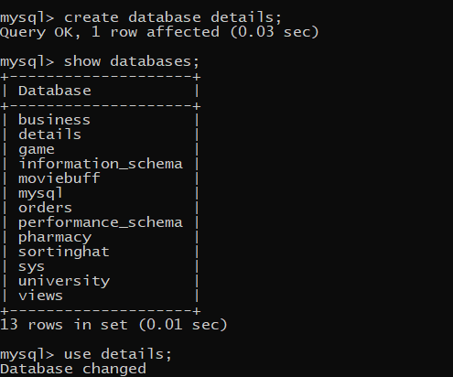

1. Create a table called “Student_Details” with the following attributes : Name,ID,Section,Marks(Max Marks 500) ,Attendance_Percentage

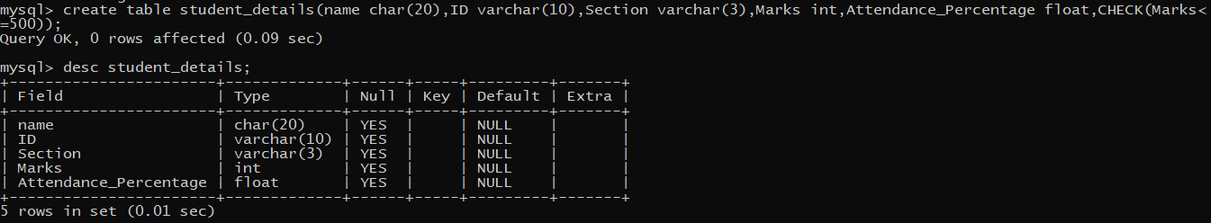

1. Insert 5 rows into it.

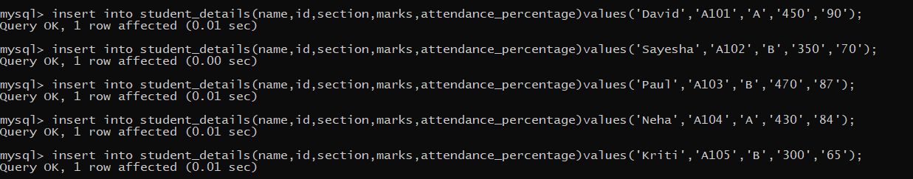

1. Display table student_details

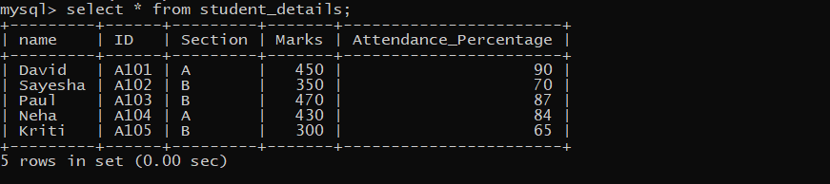

1. Create a procedure which would take input the section for ex ‘A’,’ B’ etc and returns back a count of students who have a minimum of 85% attendance and marks are above 75% (i.e. above 350 marks).

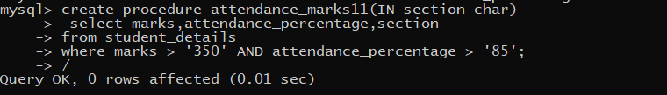

1. Execute procedure attendance_marks11

